Hello Jacob Wismer Families! Hope you all had a wonderful holiday weekend! This is the PTO newsletter, which is generally sent two times per month. This issue includes:
- Help Needed
- PTO Facebook Page
- Next PTO Meeting
- Jog-a-thon Fundraiser Update
- Scrip
- Book Fair
- Math Olympiad
- Box Tops
- Labels for Education
- Background Checks

Help Needed:
  - Picture Retake Day: Picture retakes are this Thursday, November 30 from 8:30 am – 10:30 am. We need two more volunteers to help coordinate this event. If you are able to volunteer, please sign up at myvolunteerpage.com. If your child is having a retake, their original package with photos must be returned to the photographer on retake day for your child to be photographed. If your child was absent on picture day and you would like to purchase pictures, please have your child bring in the order form with payment to school on November 30th. Please contact erinertz@gmail.com with any questions. Thanks!

  - Spring Dance Chair (or Committee) - We do not have a chair or committee for hosting a spring dance. This activity has a date in the calendar and budget for 2017-18, but will not happen without volunteer organization. Please contact Lauren Mauery (lwmauery@gmail.com) if you want more information or are interested in chairing this event.

  - One School One Book - Please contact the chair, Jennifer Politsch (marisky23@gmail.com), if you are interested in helping with this event. Help needed with activities that include setting up displays to help generate excitement throughout the school, preparing books, distribution of books/prizes, and any concluding celebration.

  - Spirit Wear Chair - Our current Spirit Wear chair is looking to pass the baton to another parent interested in helping our Jacob Wismer community. If you are interested in taking this up, please contact Jennifer Politsch (marisky23@gmail.com) for more information.

PTO Facebook Page!
Please visit Jacob Wismer Facebook page- it is another way you can stay connected with PTO activities! https://www.facebook.com/JWESPTO

PTO Meeting
The next PTO Meeting will be held on December 5th at 6:00 pm in the library. All Jacob Wismer families are welcome. Minutes will be posted shortly after the meeting on PTO website so those unable to attend can catch up.

Jog-a-thon Fundraiser Update
THANK YOU to everyone who contributed to the Jog-a-thon. This year we raised more than $65,000 for school programs. The PTO is so proud of all the hard work that the kids, teachers, staff and community did to raise money for school programs. The Jog-a-thon is the major fundraiser for the PTO and provides funds for MANY great programs such as:
Art Literacy, Passport Club, Assemblies, Classroom Resources (books, news magazines), Class Parties, Staff Appreciation, Junior Achievement, Junior Great Books, Author Visits, Field Day, One School One Book, Scholarship Programs, School-Wide Community Events (Bollywood night, Spring Dance, Movie Night), STEAM Night and Summer Reading.

Scrip
Scrip is back for the Holidays!!! Next scrip order is due on December 4th and December 11th.
Orders will be fulfilled by December 8th and December 15th respectively.
- Columbia passes valid through January 17th are available with every $50 Columbia gift card bought through Scrip in December.
- Sees Candy Forms are also due on the 4th of December. Orders will be fulfilled after the 7th of December.
The order forms are attached. You may also email your order (form not needed) to Sonia Lall at sonia1.lall@gmail.com. However, ONLY ORDERS WITH CHECKS that are deposited by the due date will be fulfilled. Thank you for considering Scrip for your holiday needs!

Book Fair
The Scholastic Winter Book Fair will be on Dec. 11-13. Hours are 8am-5pm on Dec. 11 and 12 and 8am-2pm on Dec. 13. We will need volunteer help with set up, cashiering and clean up. Shifts are set up online. Please contact Valerie at vditchfield@frontier.com for more information.

Math Olympiad:
Jacob Wismer Math Olympiads Team will have their next meeting on 12/12. We need volunteers for positions below to support the program. Please sign up at myvolunteerpage.com if you would like to help.
- Three Proctors for each meeting respectively, on the nights of 12/12, 1/16, 2/13, 3/6 [7:00pm - 8:00pm]
- Two people to help with grading after each meeting on the nights of 12/12, 1/16, 2/13, 3/6 [8:00pm - 8:30pm]
If you have any questions or need more information, please contact Joy Zhou at joy.portland@gmail.com, Thanks!

Box Tops
We have raised $722 for Jacob Wismer through our Box Top Program this school year! We are 52% away from our goal with 13 weeks left in the game. Several teams have already earned multiple rewards for remembering to bring in their Box Tops with 28 out of 29 teams already making it onto the BoxTopoly board. Good job, guys! There are several teams that just need 4 or 5 Box Tops to move a space or earn their next reward. This goes to show how every Box Top counts! We still have several months until we finish this year’s game. February 23rd, 2018 is the last collection day for this school year’s BoxTopoly so keep clipping and asking your family, friends, and neighbors for their Box Tops!

Labels for Education
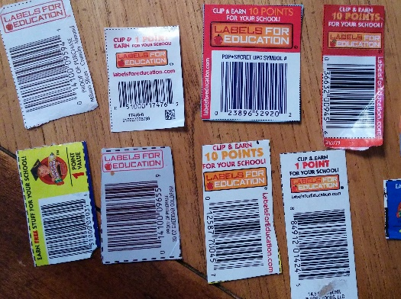

In the past few years participation in Labels for Education has declined and as a result, Campbell has decided to close the Labels for Education program (Please Note: this is completely separate from the Box Top Program). Only UPCs with the Labels for Education logo will be accepted and redeemed for points into registered schools’ bank accounts. The deadline for label submission is January 2, 2018. If you or anyone you know has a collection of these labels please send them with your student to turn into their classroom Box Top bag on or before December 20th. Our school’s label coordinator will count them and send them in to earn money for our school before the program ends. Again, please be aware that the Campbell’s Labels for Education and General Mills Box Top programs are completely separate. The Box Top program is still going strong and Jacob Wismer will continue collecting Box Tops throughout the WHOLE school year for decades to come!

Background Checks
A reminder that ALL volunteers must first complete the required District Volunteer Application and Background Check to be eligible to volunteer at Jacob Wismer.

Thank you so much for your support!
- The Jacob Wismer PTO

